Phase I and Phase II Results – Idaho (ID)

A. Plots of Predictors vs. HPI (simple returns)

Original HPI Series
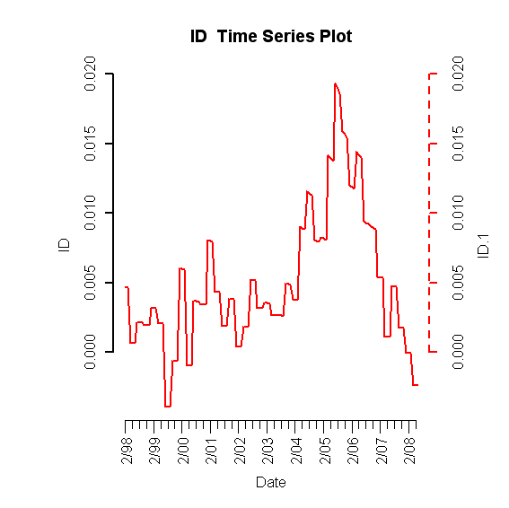

Building Permits
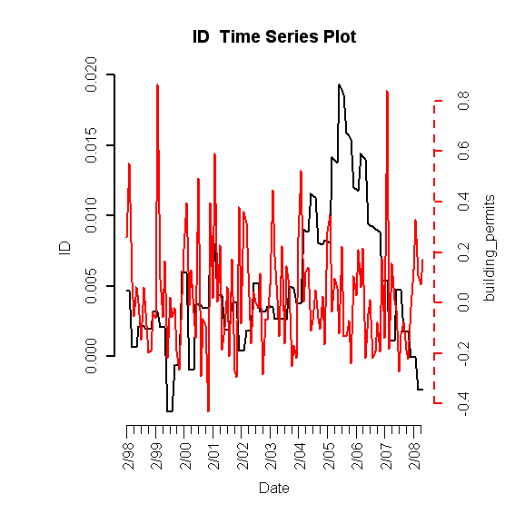

Foreclosures
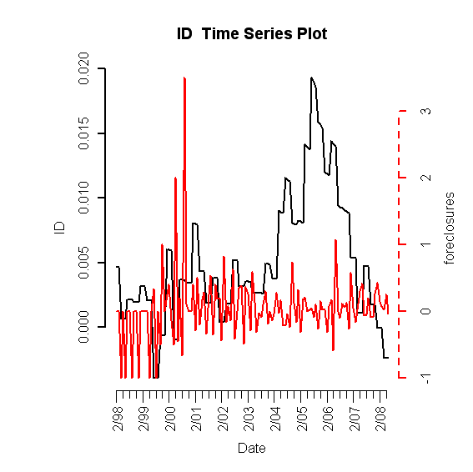
Population Size
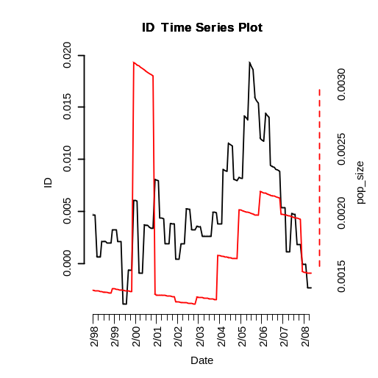

Unemployment Rate
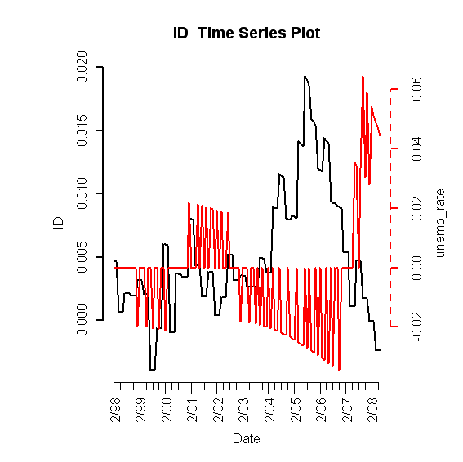
Mortgage Originations

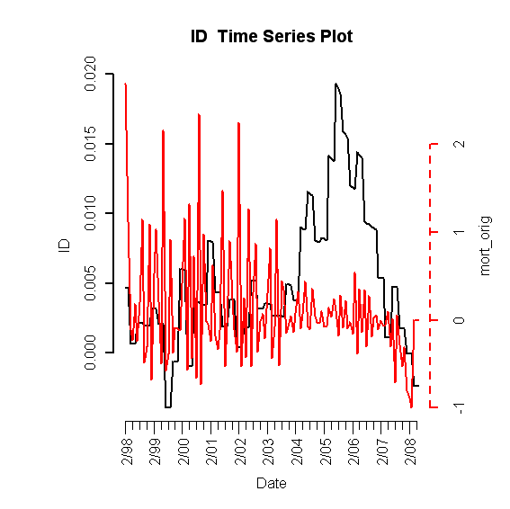

30-Year Commitment Rate
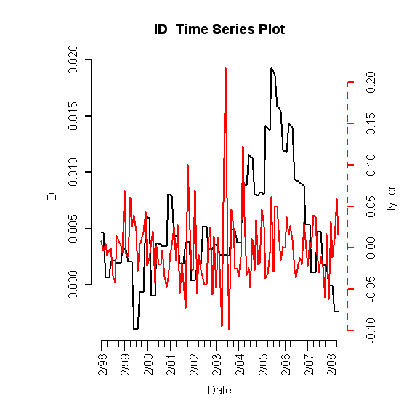

Median Income
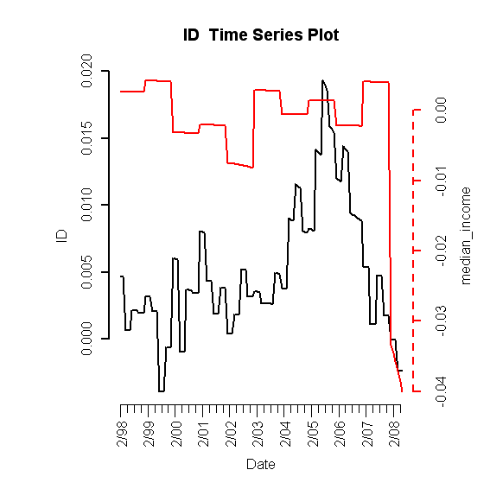
B. Plot of Lagged Predictors vs. HPI (simple returns)

Foreclosures (leading 5 months)
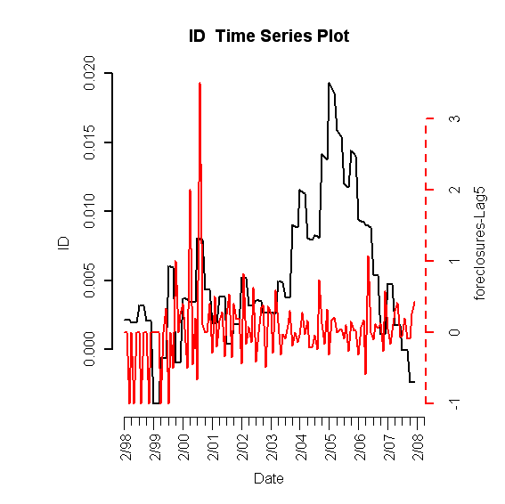

Unemployment Rate (leading 4 months)
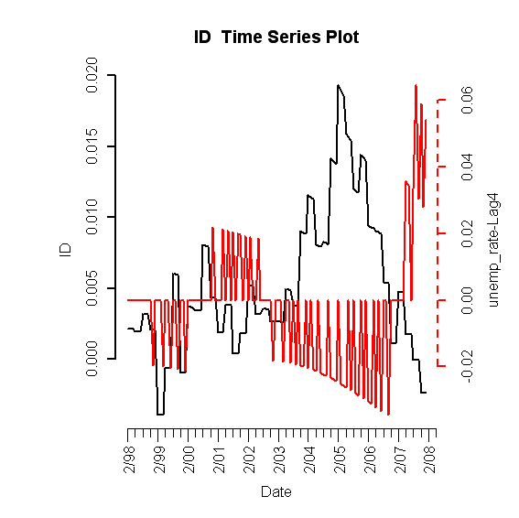

Mortgage Originations (leading 4 months)
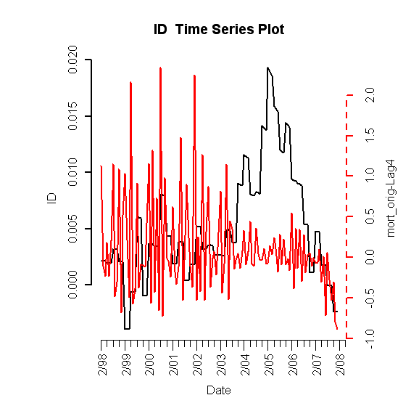

C. Scatterplots (simple return)

HPI vs. HPI
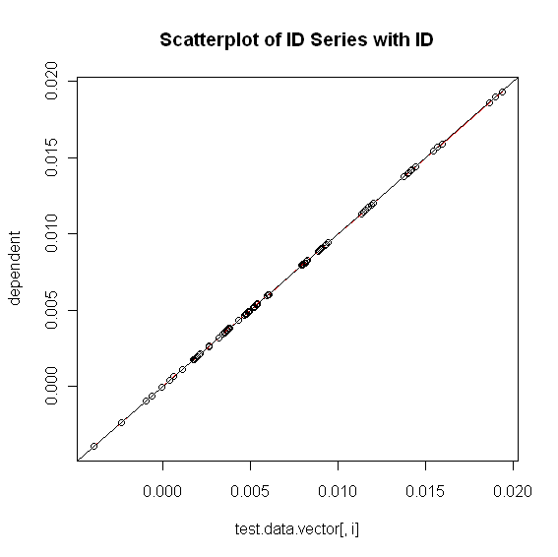

HPI vs. Building Permits
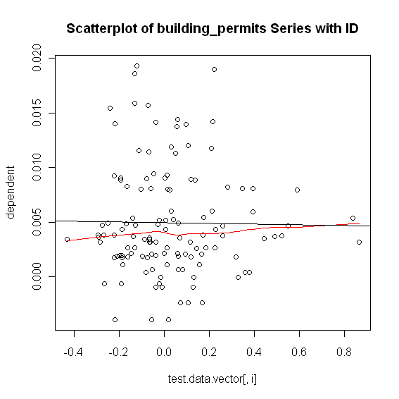
HPI vs. Foreclosures
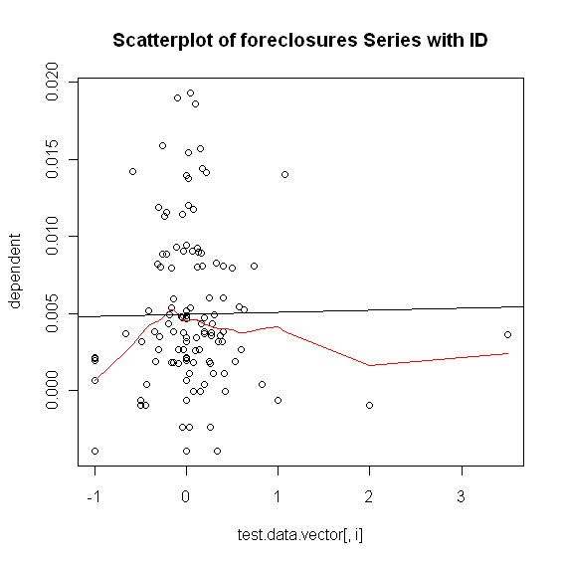

HPI vs. Population Size
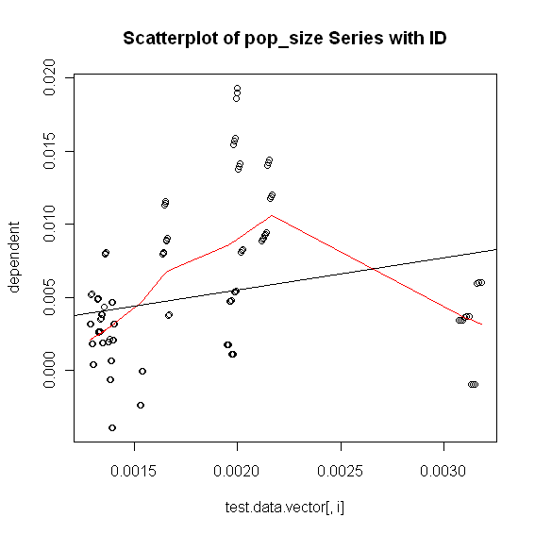

HPI vs. Unemployment Rate
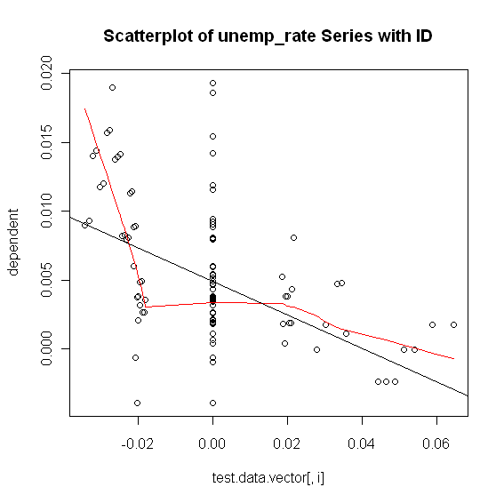

HPI vs. Mortgage Originations
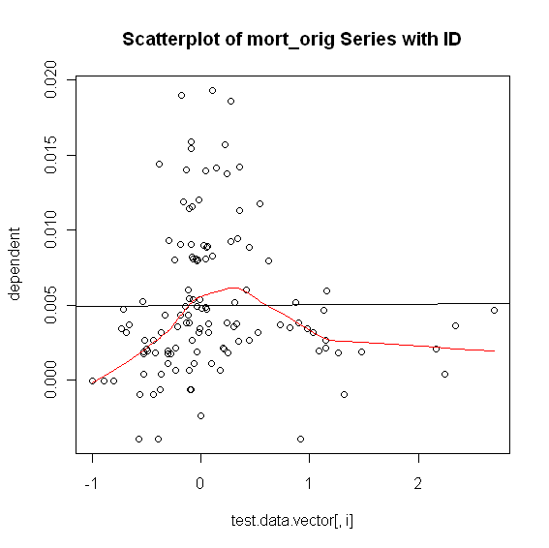

HPI vs. 30-Year Commitment Rate
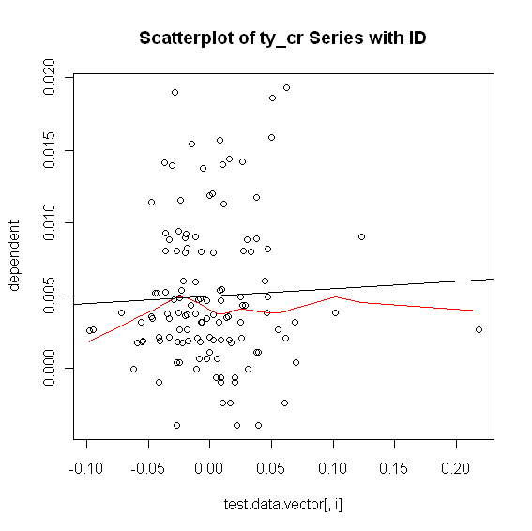

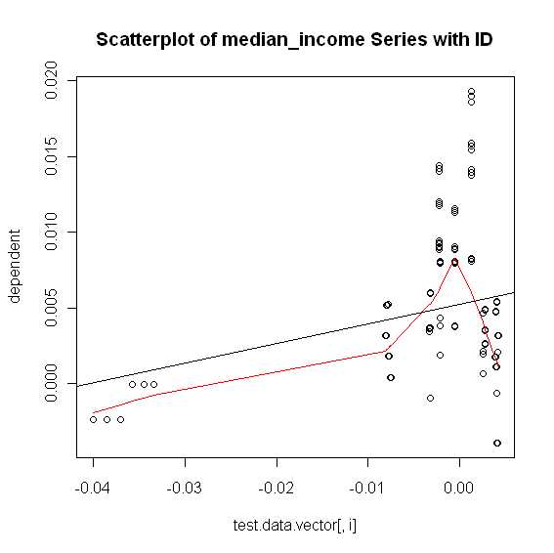

C. Final RLM Model

Robust Linear Model (significant predictors only)

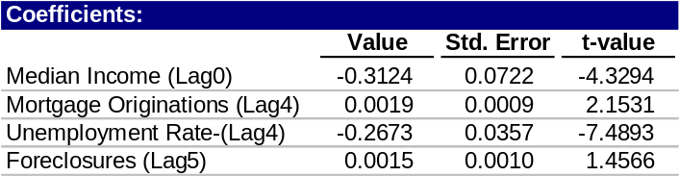

1. Phase I

ACF of Residuals
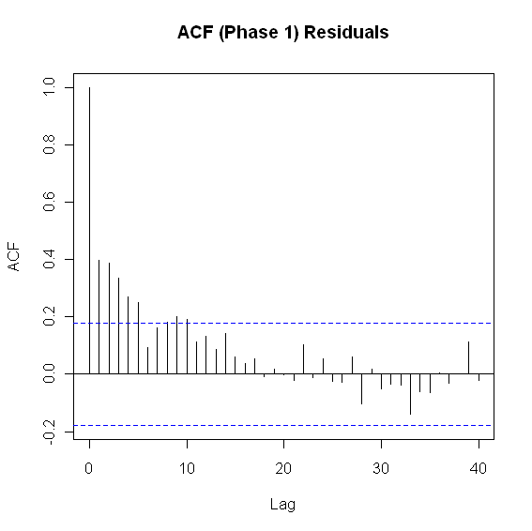

ACF of Sq-Residuals
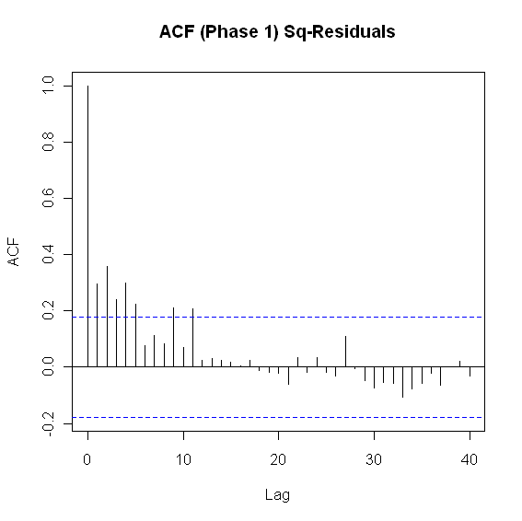
2. Phase II

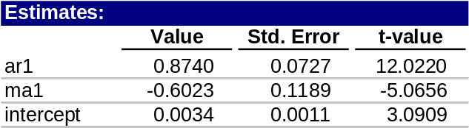

ACF of Residuals
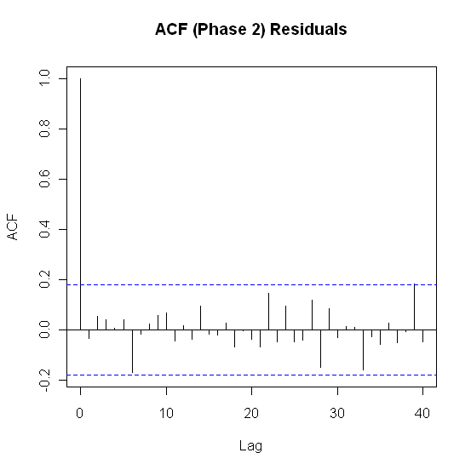

ACF of Sq-Residuals
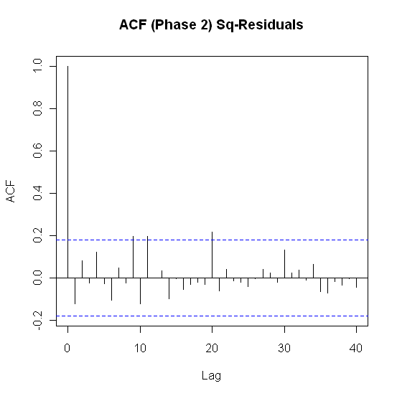
3. Model Checking Diagnostics

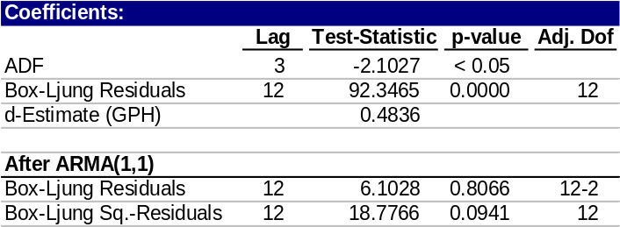

E. Fitted vs. Actual Plots

Fitted Phase 1 Fitted Values vs. HPI
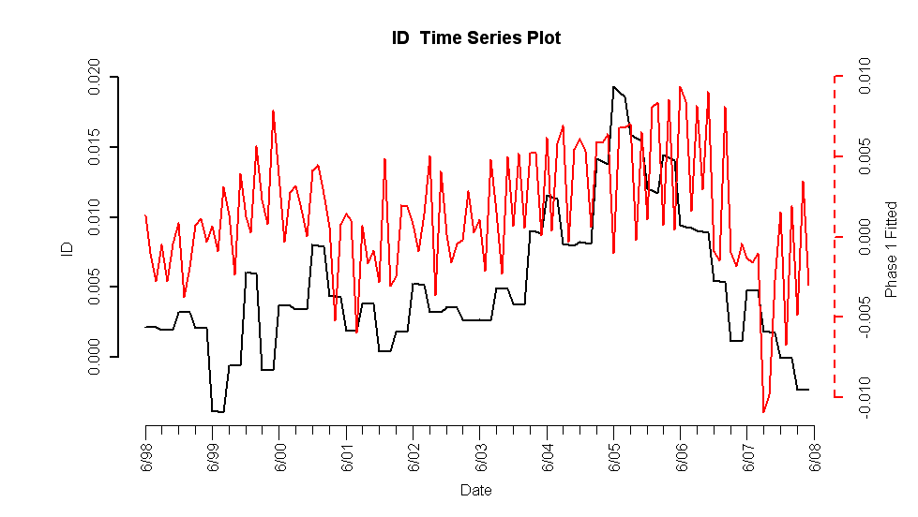
Phase1 Residuals vs. HPI
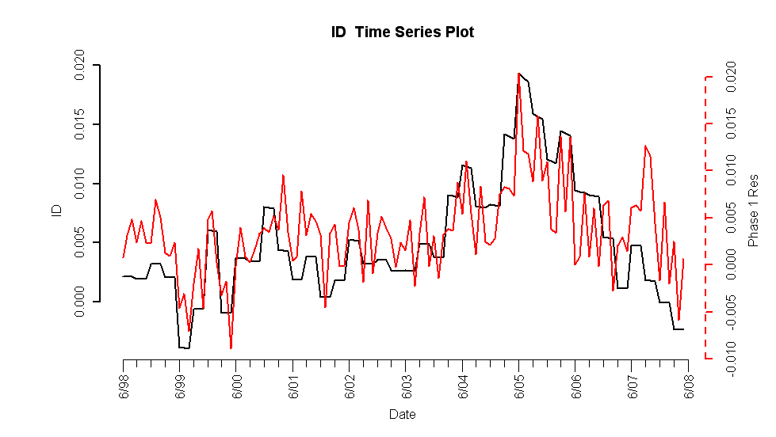

Fitted Phase 1/2 Values vs. HPI
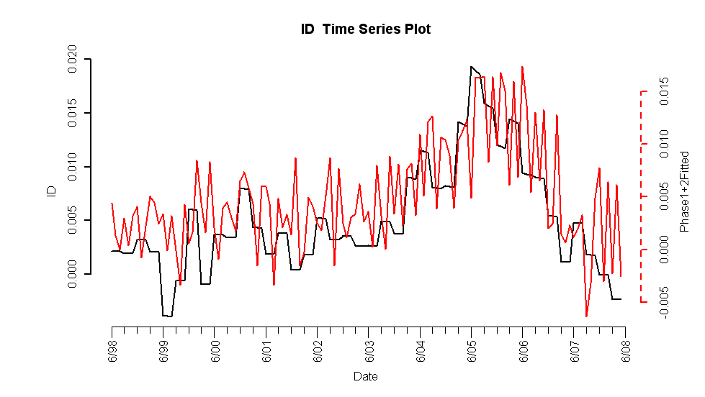

Phase 2 Residuals vs. HPI
